Title Is Limited to 50 Words
First A. Author, Fellow, IEEE, Second B. Author, and Third C. Author, Jr., Member, CSEE
Abstract—These instructions give you guidelines for preparing Rapid Communication for CSEE Journal of Power and Energy Systems. Rapid communications should present a major, novel, and original research result that is of strong interdisciplinary interest or unusual interest to the specialist. The length limitation of your papers is set up to 3 pages (2000 to 2500 words and up to Three figures). The abstract is simply a short, stand-alone summary of the work or paper that others can use as an overview, with the length up to 200 words.

Index Terms—Enter key words or phrases in alphabetical order, separated by commas, and ended with a period.

INTRODUCTION
T
HIS part is the introduction of paper, which should indicate the research background, innovation and importance of the research topic in this paper.

Methodology
This section should indicate the main idea or methodology of the research topic. Overall frame and basic theoretical support should be presented in this part. If you need to include equations and graphics, please follow the format below:

Equations
Number equations consecutively with equation numbers in parentheses flush with the right margin, as in (1). First use the equation editor to create the equation. Then select the “Equation” markup style. Press the tab key and write the equation number in parentheses. To make your equations more compact, you may use the solidus ( / ), the exp function, or appropriate exponents. Use parentheses to avoid ambiguities in denominators. Punctuate equations when they are part of a sentence, as in

(1)

Be sure that the symbols in your equation have been defined before the equation appears or immediately following. Italicize symbols of variable parameters (T might refer to temperature, but T is the unit tesla), but the non-variable illustrative subscripts of symbols should be in standard form. Refer to “(1),” not “Eq. (1)” or “equation (1),” except at the beginning of a sentence: “Equation (1) is ... .”

Types of Graphics
Screenshots are not acceptable in the CSEE journal. Generally speaking, picture-based schematic diagrams and photographs are not encouraged, and photographs must be closely related to the research of the authors themselves if they are necessary. Sizes of the graphics should be controlled so that the total size of a paper can be no larger than 4 MB. The following list outlines the different types of graphics published in the CSEE journal. They are categorized based on their construction, and use of color / shades of gray:

Color/Grayscale Figures

Figures that are meant to appear in color, or shades of black/gray. Such figures may include photographs,
illustrations, multicolor graphs, and flowcharts.

Lineart Figures

Lineart figures are composed of only black lines and shapes. These figures should have no shades or half-tones of gray. Only black and white as demonstrated in Fig. 1.
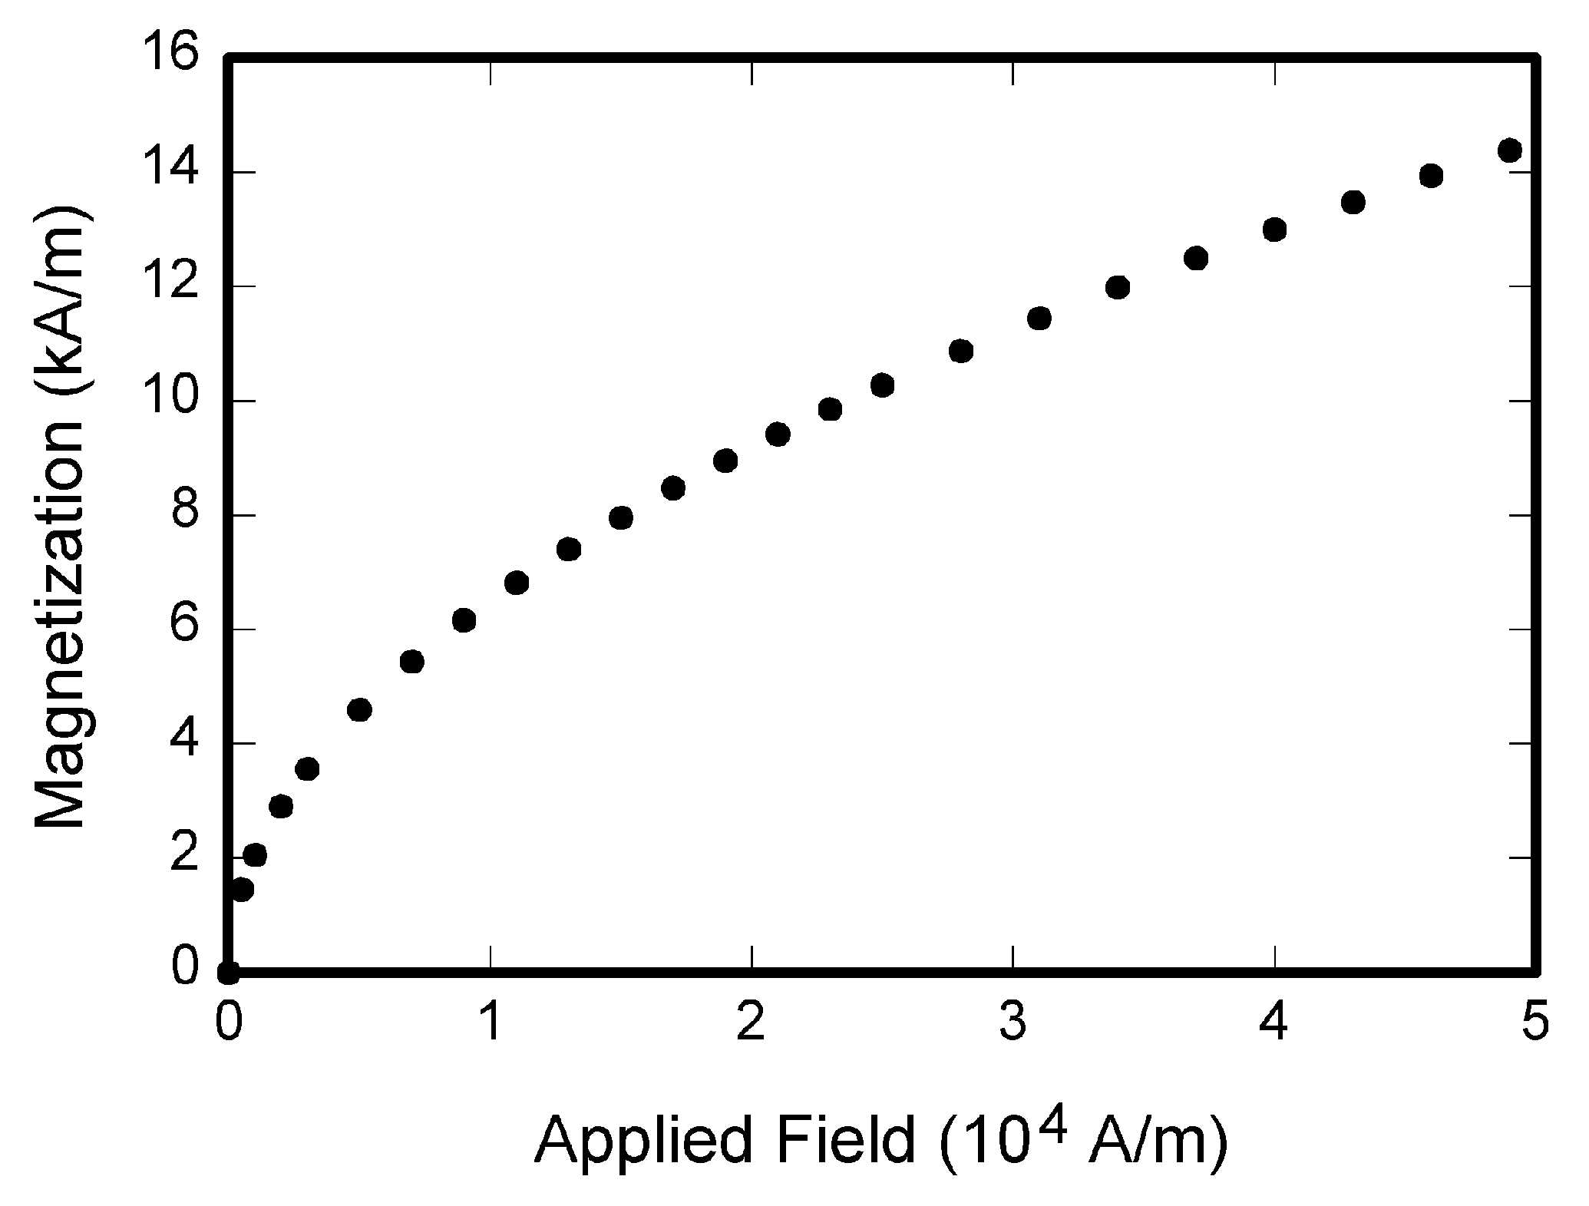
Fig. 1. Magnetization as a function of applied field. Note that “Fig.” is abbreviated. There is a period after the figure number, followed by two spaces. It is good practice to explain the significance of the figure in the caption.

Simulation
Simulation results or solution architecture is encouraged to be presented in this section, as the rapid communication is a short article mainly report the frontier idea and focus on the effectiveness, simulation part is not suggested to be presented in detail, only the results is essential to the paper.

Conclusion
A conclusion section is required, it may review the main points of the paper, do not replicate the abstract as the conclusion. A conclusion might elaborate on the importance of the work or suggest applications and extensions.

References
Basic format for books:
- J. K. Author, “Title of chapter in the book,” in Title of His Published Book, xth ed. City of Publisher, Country if not USA: Publisher, year, ch. x, sec. x, pp. xxx–xxx.
Examples:
- G. O. Young, “Synthetic structure of industrial plastics,” in Plastics, 2nd ed., vol. 3, J. Peters, Ed. New York: McGraw-Hill, 1964, pp. 15–64.
- W.-K. Chen, Linear Networks and Systems. Belmont, CA: Wadsworth, 1993, pp. 123–135.

Basic format for periodicals:
- J. K. Author, “Name of paper,” Title of Periodical, vol. x, no. x, pp. xxx–xxx, Abbrev. Month, year.
Examples:
- J. U. Duncombe, “Infrared navigation—Part I: An assessment
of feasibility,” IEEE Transactions on Electronic Devices, vol. ED-11, no. 1, pp. 34–39, Jan. 1959.
- E. P. Wigner, “Theory of traveling-wave optical laser,” Physics Review,
vol. 134, no. 3, pp. A635–A646, Dec. 1965.
- E. H. Miller, “A note on reflector arrays,” IEEE Transactions on Antennas Propagation, to be published.

Basic format for reports:
- J. K. Author, “Title of report,” Abbrev. Name of Co., City of Co., Abbrev. State, Rep. xxx, year.
Examples:
- E. E. Reber, R. L. Michell, and C. J. Carter, “Oxygen absorption in the earth’s atmosphere,” Aerospace Corp., Los Angeles, CA, Tech. Rep. TR-0200 (4230-46)-3, Nov. 1988.
- J. H. Davis and J. R. Cogdell, “Calibration program for the 16-foot antenna,” Electronic Engineering Research Laboratory, University of Texas, Austin, Tech. Memo. NGL-006-69-3, Nov. 15, 1987.

Basic format for handbooks:
- Name of Manual/Handbook, x ed., Abbrev. Name of Co., City of Co., Abbrev. State, year, pp. xxx–xxx.
Examples:
- Transmission Systems for Communications, 3rd ed., Western Electric Co., Winston-Salem, NC, 1985, pp. 44–60.
- Motorola Semiconductor Data Manual, Motorola Semiconductor Products Inc., Phoenix, AZ, 1989.

Basic format for books (when available online):
- Author. (year, month day). Title. (edition) [Type of medium]. volume (issue). Available: site/path/file
Example:
- J. Jones. (1991, May 10). Networks. (2nd ed.) [Online]. Available: http://www.atm.com

Basic format for journals (when available online):
- Author. (year, month). Title of Journal. [Type of medium]. volume (issue), pages. Available: site/path/file
Example:
- R. J. Vidmar. (1992, Aug.). On the use of atmospheric plasmas as electromagnetic reflectors. IEEE Transactions on Plasma Science. [Online]. 21(3), pp. 876–880. Available: http://www.halcyon.com/pub/journals/21ps03-vidmar

Basic format for papers presented at conferences (when available online):
- Author. (year, month). Title. Presented at Conference title. [Type of Medium]. Available: site/path/file
Example:
- PROCESS Corp., MA. Intranets: Internet technologies deployed behind the firewall for corporate productivity. Presented at
INET96 Annual Meeting. [Online]. Available: http://home.process.com/Intranets/wp2.htp

Basic format for reports and handbooks (when available online):
- Author. (year, month). Title. Company. City, State or Country. [Type of Medium]. Available: site/path/file
Example:
- S. L. Talleen. (1996, Apr.). The Intranet Architecture: Managing information in the new paradigm. Amdahl Corp., CA. [Online]. Available: http://www.amdahl.com/doc/products/bsg/intra/infra/html

Basic format for computer programs and electronic documents (when available online): ISO recommends that capitalization follow the accepted practice for the language or script in which the information is given.
Example:
- A. Harriman. (1993, Jun.). Compendium of genealogical software. Humanist. [Online]. Available e-mail: HUMANIST@NYVM.ORG Message: get GENEALOGY REPORT

Basic format for patents (when available online):
- Name of the invention, by inventor’s name. (year, month day). Patent Number [Type of medium]. Available: site/path/file
Example:
Musical toothbrush with adjustable neck and mirror, by L. M. R. Brooks. (1992, May 19). Patent D 326 189 [Online]. Available: NEXIS Library: LEXPAT File: DESIGN

Basic format for conference proceedings (published):
- J. K. Author, “Title of paper,” in Name of Conference, City of Conference, Abbrev. State (if given), year, pp. xxx–xxx.
Example:
- D. B. Payne and J. R. Stern, “Wavelength-switched passively coupled single-mode optical network,” in Proceedings of IOOC-ECOC,1985,
pp. 585–590.
Example for papers presented at conferences (unpublished):
- D. Ebehard and E. Voges, “Digital single sideband detection for interferometric sensors,” presented at the 2nd International Conference on Optical Fiber Sensors, Stuttgart, Germany, Jan. 2–5, 1984.

Basic format for patents:
- J. K. Author, “Title of patent,” U.S. Patent x xxx xxx, Abbrev. Month, day, year.
Example:
- G. Brandli and M. Dick, “Alternating current fed power supply,”
U.S. Patent 4 084 217, Nov. 4, 1978.
Basic format for theses (M.S.) and dissertations (Ph.D.):
- J. K. Author, “Title of thesis,” M.S. thesis, Department, University, City of University, Abbrev. State, year.
- J. K. Author, “Title of dissertation,” Ph.D. dissertation, Department, University, City of University, Abbrev. State, year.
Examples:
- J. O. Williams, “Narrow-band analyzer,” Ph.D. dissertation, Department of Electric Engineering, Harvard University, Cambridge, MA,1993.
- N. Kawasaki, “Parametric study of thermal and chemical nonequilibrium nozzle flow,” M.S. thesis, Department Electronic Engineering, Osaka University, Osaka, Japan, 1993.
Basic format for the most common types of unpublished references:
- J. K. Author, private communication, Abbrev. Month, year.
- J. K. Author, “Title of paper,” unpublished.
- J. K. Author, “Title of paper,” to be published.
Examples:
- A. Harrison, private communication, May 1995.
- B. Smith, “An approach to graphs of linear forms,” unpublished.
- A. Brahms, “Representation error for real numbers in binary computer arithmetic,” IEEE Computer Group Repository, Paper R-67-85.

Basic format for standards:
- Title of Standard, Standard number, date.
Examples:
- IEEE Criteria for Class IE Electric Systems, IEEE Standard 308, 1969.
- Letter Symbols for Quantities, ANSI Standard Y10.5-1968.

First A. Author (M’76–SM’81–F’87) and the other authors may include biographies at the end of regular papers. Biographies are often not included in conference-related papers. This author became a Member (M) of IEEE in 1976, a Senior Member (SM) in 1981, and a Fellow (F) in 1987. The first paragraph may contain a place and/or date of birth (list place, then date). Next, the author’s educational background is listed. The degrees should be listed with type of degree in what field, which institution, city, state, and country, and year the degree was earned. The author’s major field of study should be lower-cased.
The second paragraph uses the pronoun of the person (he or she) and not the author’s last name. It lists military and work experience, including summer and fellowship jobs. Job titles are capitalized. The current job must have a location; previous positions may be listed without one. Information concerning previous publications may be included. Try not to list more than three books or published articles. The format for listing publishers of a book within the biography is: title of book (city, state: publisher name, year) similar to a reference. Current and previous research interests end the paragraph.
The third paragraph begins with the author’s title and last name (e.g., Dr. Smith, Prof. Jones, Mr. Kajor, Ms. Hunter). List any memberships in professional societies other than the IEEE. Finally, list any awards and work for IEEE committees and publications. If a photograph is provided, the biography will be indented around it. The photograph is placed at the top left of the biography, and should be of good quality, professional-looking, and black and white (see above example). Personal hobbies will be deleted from the biography. Following are two examples of an author’s biography.

Second B. Author received the B.S. and M.S. degrees in aerospace engineering from the University of Virginia, Charlottesville, in 2001 and the Ph.D. degree in mechanical engineering from Drexel University, Philadelphia, PA, in 2008.
From 2001 to 2004, he was a Research Assistant with the Princeton Plasma Physics Laboratory. Since 2009, he has been an Assistant Professor with the Mechanical Engineering Department, Texas A&M University, College Station. He is the author of three books, more than 150 articles, and more than 70 inventions. His research interests include high-pressure and high-density nonthermal plasma discharge processes and applications, microscale plasma discharges, discharges in liquids, spectroscopic diagnostics, plasma propulsion, and innovation plasma applications. He is an Associate Editor of the journal Earth, Moon, Planets, and holds two patents.
Mr. Author was a recipient of the International Association of Geomagnetism and Aeronomy Young Scientist Award for Excellence in 2008, the IEEE Electromagnetic Compatibility Society Best Symposium Paper Award in 2011, and the American Geophysical Union Outstanding Student Paper Award in Fall 2005.

_____________________________________ This paragraph of the first footnote will contain the date on which you submitted your paper for review. It will also contain support information, including sponsor and financial support acknowledgment. For example, “This work was supported in part by the National Natural Science Foundation of China under Grant xxxxxxx. The next few paragraphs should contain the authors’ current affiliations, including current address and e-mail. For example, F. A. Author is with the National Institute of Standards and Technology, Boulder, CO 80305 USA. S. B. Author, Jr. (corresponding author, e-mail: author@lamar.colostate.edu), was with Rice University, Houston, TX 77005 USA. He is now with the Department of Physics, Colorado State University, Fort Collins, CO 80523 USA. T. C. Author is with the Electrical Engineering Department, University of Colorado, Boulder, CO 80309 USA, on leave from the National Research Institute for Metals, Tsukuba, Japan. DOI:

